

St Finlough’s Primary School (Sistrakeel)

138 Tartnakelly Road

Glack

Limavady

County Derry

BT49 9JL

Tel/Fax: 028 77763848

Principal: Mrs S McCafferty *B. Ed, M.Ed, PQHNI*

*www.stfinloughssistrakeel.co.uk*

email: smccafferty143@c2kni.net



Dear Parents/Guardians,

**Health, Fitness, and Wellbeing in January 2020**

**UNCRC Article 24: Every child has the right to the best possible health.**

Happy New Year and welcome back to school! I am writing to inform you of our initiatives which we will be promoting in January 2020. Health, fitness and wellbeing is very important here at St. Finlough’s PS, and we would like to kick start the new year with this in mind. Our Smart Snacks & Healthy Eating & Oral Health policies can be found at (for further guidance and healthy lunch box ideas):

<https://www.stfinloughssistrakeel.co.uk/our-school/policies/>

Details are as follows/permission slips:

|  |  |  |
| --- | --- | --- |
| **Who?** | **What?** | **When?** |
| Primary 1-7 | Breakfast Club | Daily from 8.10am £1 |
| Primary 1-7 | Healthy Break: fruit, milk & water | Daily (£5 per month for fruit & £5 per month for milk). |
| Primary 1-7 | Healthy Lunch Box Challenge | Daily |
| Primary 1-7 | The Daily Mile | Daily (A Coat & Water should be brought to school each day) |
| Primary 1-7 | We would encourage as many families to walk, cycle or scoot to school.  High-vis vests are available from the school office. Parents/guardians must accompany the children. | The month of January |
| Primary 1-5 | Musical Pathways to Learning | Wednesdays in school £1 |
| Primary 1-7 | Kick-start Soccer Afterschool Club | Thursday 2-4pm |
| Primary 4-7 | Gaelic Afterschool Club with Andrena | Wednesday 3-4pm |
| Primary 1-7 | Gaelic/games Coaching in school | Thursdays |
| Primary 6&7 | Schools Swimming Programme | 8th & 15th January |
| Primary 1-7 | Gaelic Training with O’Connor’s, Glack GAC @St. Finlough’s Parish Hall. New players welcome!  Aaron O’Connor: 07892701731 | Fridays starting 10th January £2  P1-3 7-8pm  P4-7 8-9pm |
| Primary 1/2 | ‘The joy of play’ afterschool club | Tuesdays in January 2-3pm £1  7/1/20, 14/1/20, 21/1/20 & 28/1/20 |
| Primary 3 | Dance afterschool club with Miss Herron | Tuesdays in January 3-4pm £1  7/1/20, 14/1/20, 21/1/20 & 28/1/20 |
| Primary 4/5 | Weaving club with Mrs McCafferty | Tuesdays in January 3-4pm £1  7/1/20, 14/1/20, 21/1/20 & 28/1/20 |
| Primary 6 & 7 | Relaxation afterschool club with Mrs Morrison | Tuesdays in January 3-4pm £1  7/1/20, 14/1/20, 21/1/20 & 28/1/20 |
| Primary 4 & 5 | Dry Arch GROW Programme  Resiliency & Mental Health  (During school) | Thursdays 6 weeks:  16/1/20, 30/1/20, 6/2/20, 13/2/20,20/2/20, 27/2/20 |
| Primary 6 & 7 | Dry Arch Resiliency & Mental Health programme | To be confirmed…. |
| **Parents/Guardians of the School** | **FREE ‘Introduction to Fitness’ sessions with Jordan @ Element Fitness. 14 Sistrakeel Road.**   * **No previous experience necessary** * **All abilities welcome!** | **Tuesday 14th January &**  **Thursday 16th January**  **8-9pm** |
| **Parents/Guardians of the School** | **FREE ‘Healthy Meals for the Family: Cookery Demonstration’ @ Drummond Hotel, Ballykelly.** | **Wednesday 22nd January 7pm** |
| Road Safe NI Road Safety Quiz | 4x Primary 7 children | Tuesday 28th January 10-11.30am @ Lodge Hotel, Coleraine. |
| Primary 1 & 2 | Oral hygiene visit from Catherine Street Dental Surgery | Thursday 30th January  (In school 11am -12noon) |

Thank you to our sponsors/ facilitators….

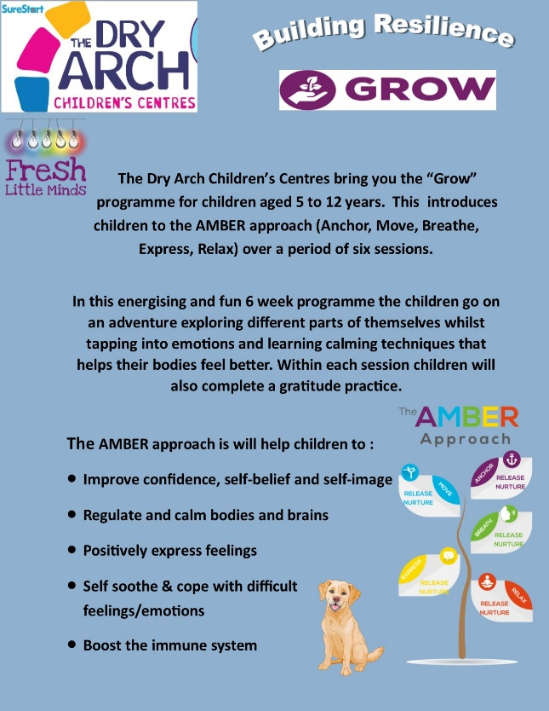

 [](http://www.glackgaa.ie/) [](https://www.bing.com/images/search?view=detailV2&ccid=4HMwrUzH&id=687165636D32FB293DE54E249D205DA2D08E1C53&thid=OIP.4HMwrUzHT7Equ2DMafoDFgAAAA&mediaurl=https://pbs.twimg.com/profile_images/745239567469580288/8wep34mH_400x400.jpg&exph=400&expw=400&q=dry+arch&simid=608026300200716071&selectedIndex=4&adlt=strict)[](https://www.bing.com/images/search?view=detailV2&ccid=vbFNXX%2bd&id=1364CC346ADF290574A82CCDE16C120DF3DB66C4&thid=OIP.vbFNXX-duji_-Ru1ZcgZOwHaDQ&mediaurl=http://www.st-williams.bolton.sch.uk/wp-content/uploads/2018/01/daily-mile-logo-1180x520.jpg&exph=520&expw=1180&q=daily+mile&simid=608055497414805795&selectedIndex=1&adlt=strict) [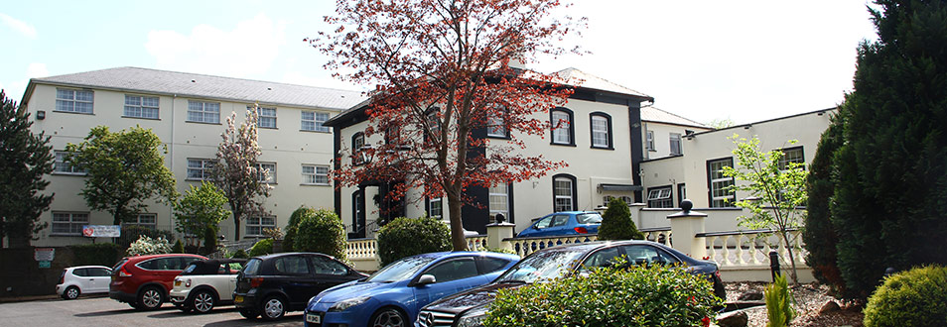](https://www.drummondhotel.com/) [](https://www.drummondhotel.com/)

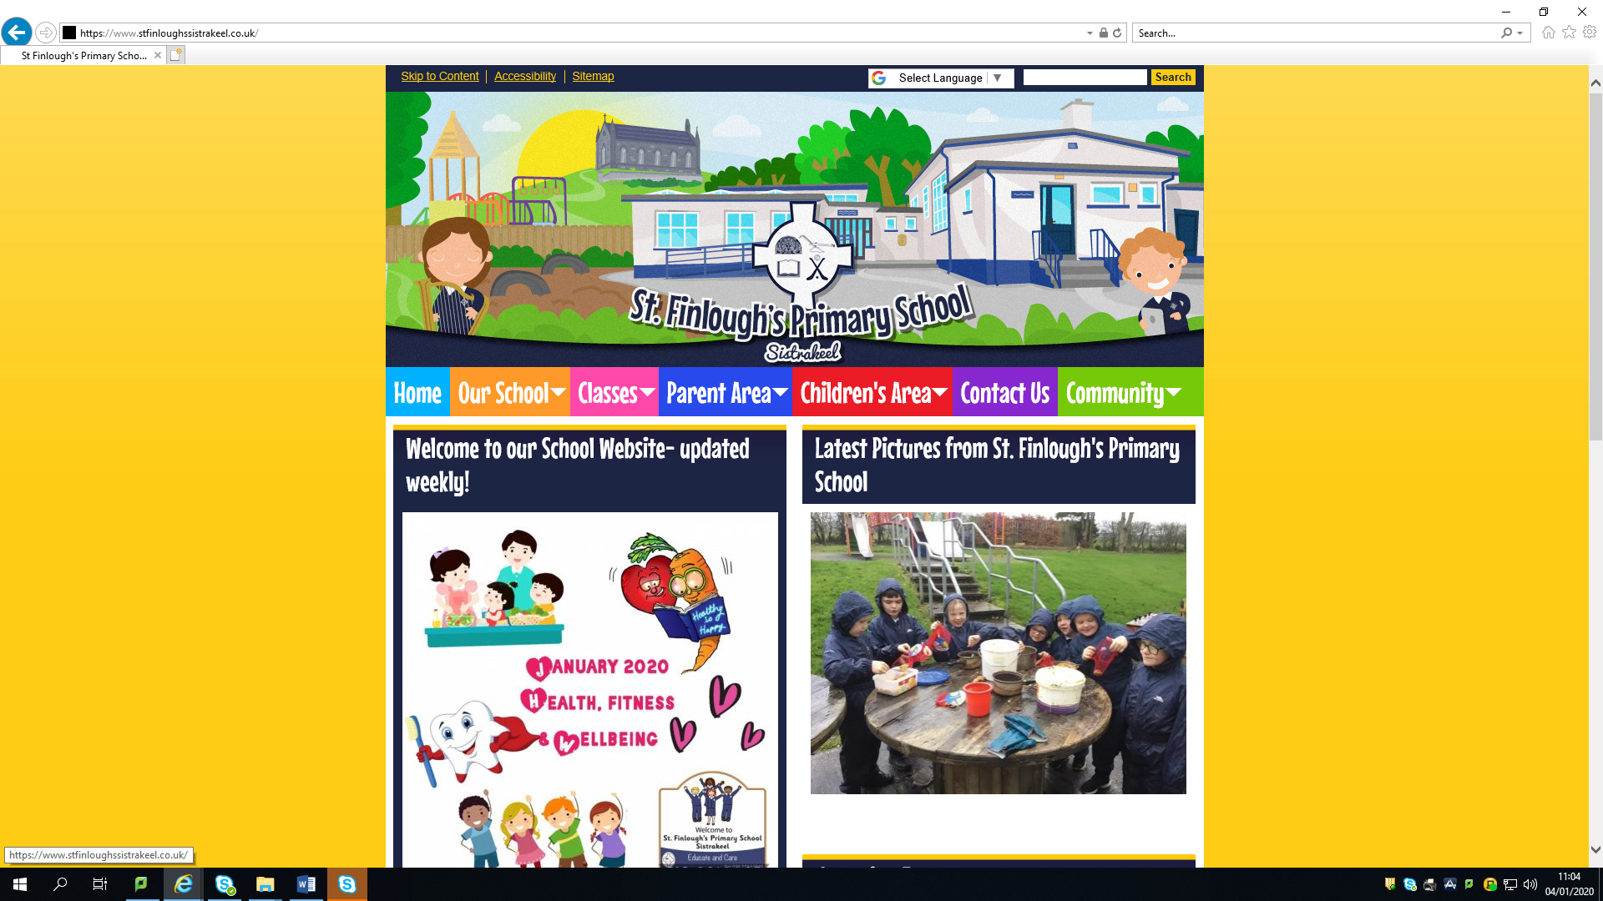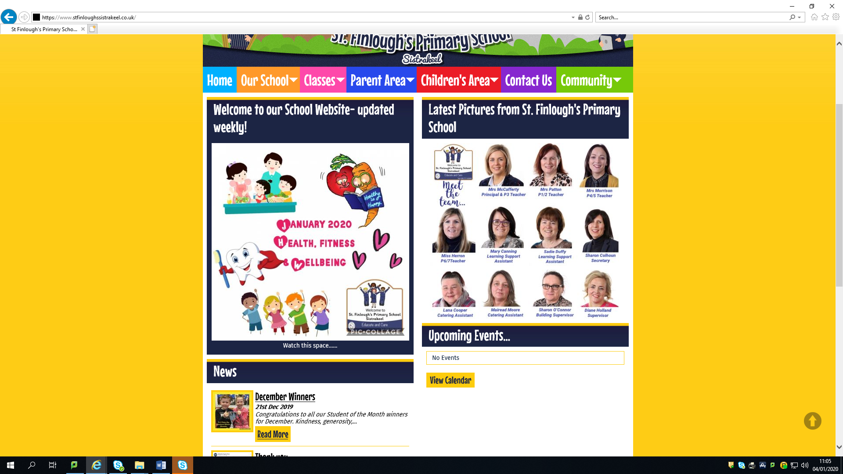

**Permission slip.**

Please return to your child’s class teacher tomorrow for clubs to commence on Tuesday 7th January. Gaelic and Kick start afterschool clubs will run as normal-new members always welcome.

Name of child: ______________________ Class:___________

My child will/will not be participating in the following after school club:

|  |  |
| --- | --- |
| **Club** | **Attending?** |
| P1/2 The joy of Play |  |
| P3 Dance |  |
| P4/5 Weaving |  |
| P6/7 Relaxation |  |

I am interested in the following initiatives:

|  |  |
| --- | --- |
| **Initiative** | **Interested/Attending?** |
| Introduction to fitness @ Element fitness |  |
| Healthy Meals for the family cookery demonstration @ The Drummond Hotel |  |

Signed:_______________________________

Thankyou for your continued support of the school,

Yours Sincerely,

______________________________

Mrs S. McCafferty