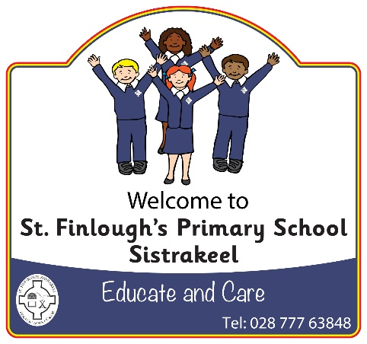

**St Finlough’s Primary School (Sistrakeel)**

**138 Tartnakelly Road**

**Glack**

**Limavady**

**County Derry**

**BT49 9JL**

**Tel/Fax: 028 77763848**

**Principal: Mrs S McCafferty *B. Ed, M.Ed, PQHNI***

**email: smccafferty143@c2kni.net**

**www.stfinloughssistrakeel.co.uk**



Dear Parents/Guardians,

I am writing to inform you of upcoming important dates. At time of printing these arrangements were correct, however if they should change we will inform you ASAP.

|  |  |
| --- | --- |
| **Date/Time/Location** | **Event** |
| Friday 19th October @1.30pm in school | Opening of the school year celebratory mass- all welcome |
| Monday 22nd, 23rd & 24th October 3-5pm | Parents meetings |
| Wednesday 24th October @2.15pm in school | Primary 4 First Holy Communion Enrolment service |
| Thursday 25th October (7-8pm P1-3),  (8-9.30pm P4-7) in school | Halloween disco |
| Friday 26th October | Halloween fancy dress |
| Thursday 15th November in school | Scholastic Book Fayre |
| Monday 19thNovember @10-11.10am Roe Valley Cultural & Arts Centre  Animation Workshop in connection with the Nerve Centre, held in school | P1-3 Into film festival  P4-7 Animation |
| Tuesday 20th November @10-12.10pm Roe Valley Cultural & Arts Centre | P4-7 Into Film Festival |
| Thursday 22nd November 10-11.30am | OPEN MORNING |
| Thursday 22nd November | Dress up as book character & Singing with Tom Sweeney |
| Thursday 13th December 10am in school | Primary1-3 Nativity show for Nursery children |
| Friday 14th December 10am in school | Primary 1-3 Nativity show for Parents/guardians & families. |
| Monday 17th December @ 7pm in St. Finlough’s Chapel | School Carol Service |
| Saturday 9th March @11am in Christ the King Chapel | Confirmation |
| Sunday 2nd June @ 10am in St. Finlough’s Chapel | First Holy Communion |
| Thursday 6th June in Celtic Park | Fan the Flame Primary 7 Mass |

Yours Sincerely,

________________________

Mrs Suzann McCafferty