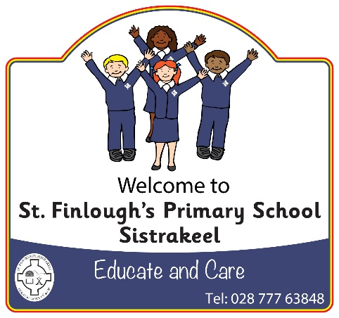



St Finlough’s Primary School (Sistrakeel)

138 Tartnakelly Road

Glack

Limavady

County Derry

BT49 9JL

Tel/Fax: 028 77763848

Principal: Mrs S McCafferty *B. Ed, M.Ed, PQHNI*

*www.stfinloughssistrakeel.co.uk*

email: smccafferty143@c2kni.net



Dear Parents/Guardians,

I am writing to inform you of our arrangements for parent/guardian meetings this academic year. **There will be meetings held in February for all pupils**. More information regarding this will follow in due course, but I anticipate that they will be held the week beginning Monday 8th February.

Due to covid-19 restrictions, we are encouraging parents and guardians, not to enter the school building unless a prior appointment has been arranged. Thank you for your co-operation. Staff can be contacted via phone or email.

**October Meetings.**

**There will be parent/guardian meetings held in the school for Primary 1 and Primary 7 children, as well as children who require an Individual Education Plan. Parents of any new children to our school in the last few months will also be invited to attend as well as any others which the teacher feels is appropriate at this time. These meetings will take place, week beginning Monday 19th October**.

Individual times will be given to families. If you are unable to make your appointment, please phone Sharon at the school office. 15 minutes has been allocated for each appointment. Please exercise social distancing when in the school. We would also encourage you to wear a mask during the meeting.

Thank you for all your help and support in ensuring our school community stays safe.

Kind regards,

Mrs S. McCafferty