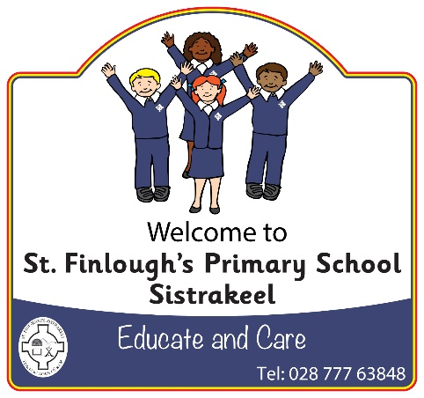

Christmas Calendar

Wednesday 13 December School Choir Singing at Cornfields Nursing Home, 10.30am

After Schools P1/2 Numeracy
P3 Irish
P4/5 Numeracy
P6/7 ICT Games

Thursday 14 December P1-P3 Play ‘The Sleepy Shepherd’ 10.15am
Admission £2.50 Everyone Welcome

School Christmas Dinner

Friday 15 December P1-P3 Play ‘The Sleepy Shepherd’ 10.15am
Orchard Play Group Performance (Parents welcome)

Monday 18 December A surprise ‘Special Guest’ to see all the children, Ho! Ho! Ho!

Tuesday 19 December P4-P7 Carol Service at St Finlough’s Church at 7pm
The whole school and their families and friends all welcome

Wednesday 20 December Class Christmas Parties
NO After Schools Clubs

Thursday 21 December Children finish at 11.30am. Dinner served early.
Grand Christmas Raffle Draw at 11.30am

Thursday 21 December is non-uniform day. Children are welcome to wear their Christmas jumpers or Christmas accessories from Monday 18 December.

